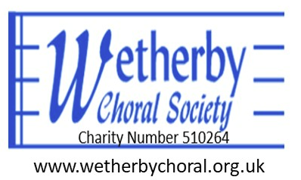

Choral Scholarship Opportunity for Tenors & Basses
Wetherby Choral Society is pleased to announce applications are now open for our Choral Scholarship Programme, starting in Autumn 2026.
We are seeking two Choral Scholars (one Tenor and one Bass) aged 18 to 30. This scheme is ideal for university students, gap-year singers, or advanced young musicians looking to broaden their repertoire, enhance their ensemble singing, and gain valuable performance experience alongside a large, vibrant choir.

About Wetherby Choral Society
Founded in 1974, Wetherby Choral Society is a welcoming choir of well over 100 members. We perform a wide range of works—from classic masterworks by Bach, Handel, and Mozart to contemporary music by John Rutter and Karl Jenkins. We present 3 to 4 major concerts each year at St James' Church in Wetherby, alongside occasional performances at major venues such as Ripon Cathedral.
Our Music Director is Charlie Murray, who has led the choir through his very successful first year. He took over from John Dunford at the start of the 2025-26 season.

Key Details & Benefits
- Rehearsals: Mondays during term time, 19:30–21:30 at St James' Church, Wetherby (LS22 6LP).
- Commitment: ~30–35 weekly rehearsals across the academic year (must include the final two rehearsals before each concert), plus 4 concerts.
- Stipend: £300 per term (subject to regular attendance and participation in concerts).
- Perks: Free sheet music hire, occasional solo performance opportunities, and two complimentary tickets per concert.

Requirements & Responsibilities
- Attend at least 80% of weekly term-time rehearsals and all concerts.
- Demonstrate strong vocal technique, musicality, and confident sight-reading skills.
- Actively contribute to the tenor or bass section, and to the musical life of the choral society.

How to Apply
To apply or express interest in either the Tenor or Bass vacancy, please email a brief CV and a short introductory note detailing your musical background to secretary@wetherbychoral.org.uk.
- Website: www.wetherbychoral.org.uk
- Contact Phone: 07926 194006
Auditions and informal interviews will be arranged individually upon application.

