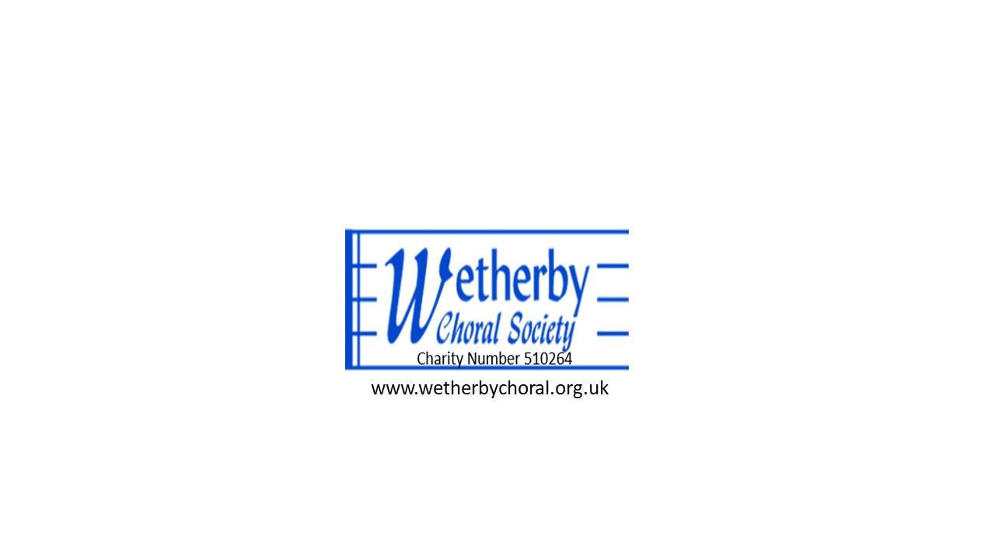
Agenda for the Annual General Meeting

Monday 13th October 2025 7.30pm St James’s Church Wetherby

1. Apologies

2. Minutes of the meeting held on 21 October 2024 – for approval (see attached)

3. Chairman’s Report (see attached)

4. Treasurer’s Report and Financial Accounts (see attached)

5. Musical Director’s Report (see attached)

6. Election of Committee members
(Nominations to be emailed to the Secretary by 12 October).

7. Election of Chairman and Treasuerer
(Nominations to be emailed to the Secretary by 12 October).

8 Any other business
(Please advise the Secretary by email in advance if you wish to raise anything)

30 September 2025

Malcolm Smith
Secretary, Wetherby Choral Society
mdsmith55@gmail.com
Tel: 07926 194006

